**Project for Robotics**

**(MCTE4352/MCT4215)**

**SEMESTER 2, 2019/2020 SESSION**

**Lecturer: Dr. Tanveer Saleh**

*By:*

*Muhammad Azhar bin syed jowbur ali*

*1719949*

**Introduction**

This project is about making a closed loop using scara robot. To do this we must first design our desired robot and get the DH table from the robot. Then we need to get the DH matrix and comparing the result x y z value with our desired x y z value and do the inverse kinematics, we can get the Theta 1, theta 2, theta 4 (not needed in this project) and the L3(prismatic length). By using the theta 1, theta 2 and prismatic length (L3), we managed to move the scara robot in a closed loop which will be discussed below.

**Using Pen and paper (or excel)**

1. SCARA robot is design and its DH matrix formed.

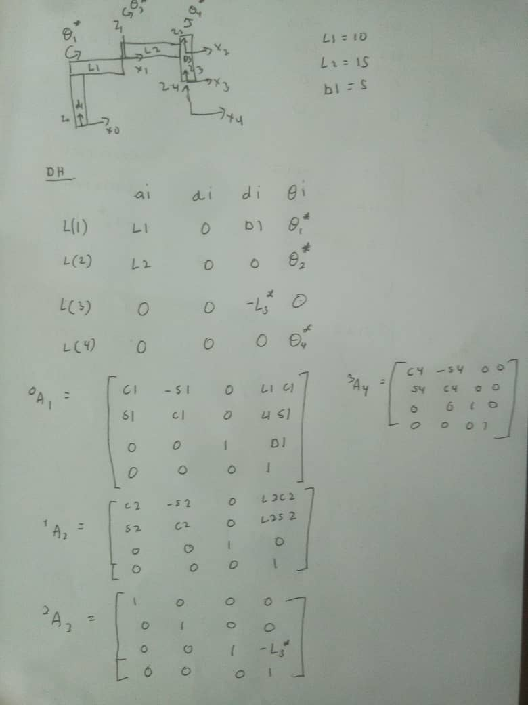

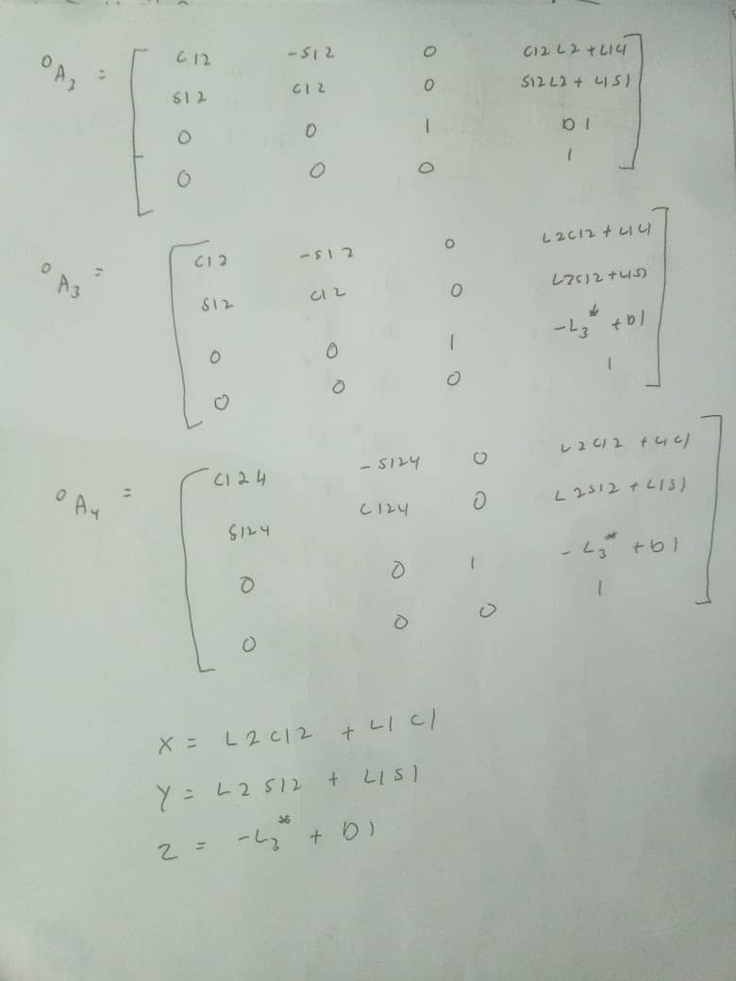

1. The Theta 1,2 and L3 formula and the closed loop path

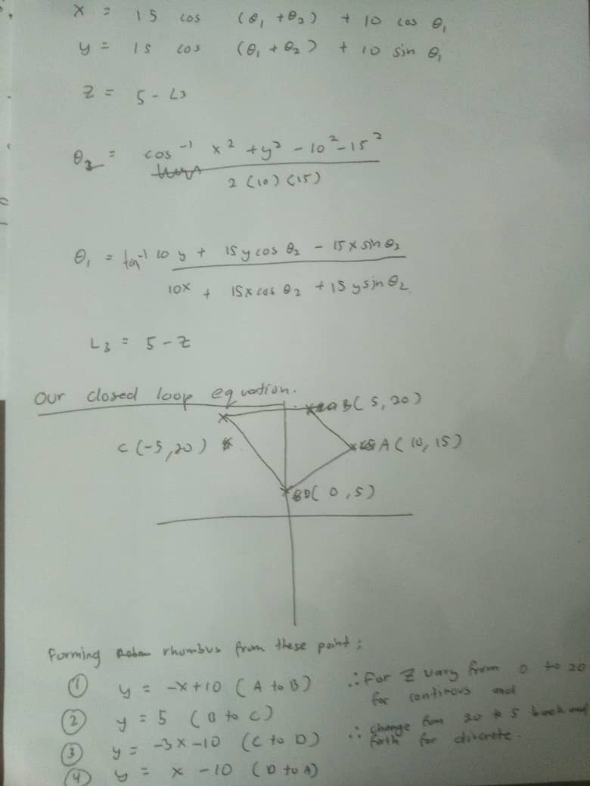

1. The value of X, Y, Z, Theta 1, Theta 2, L3

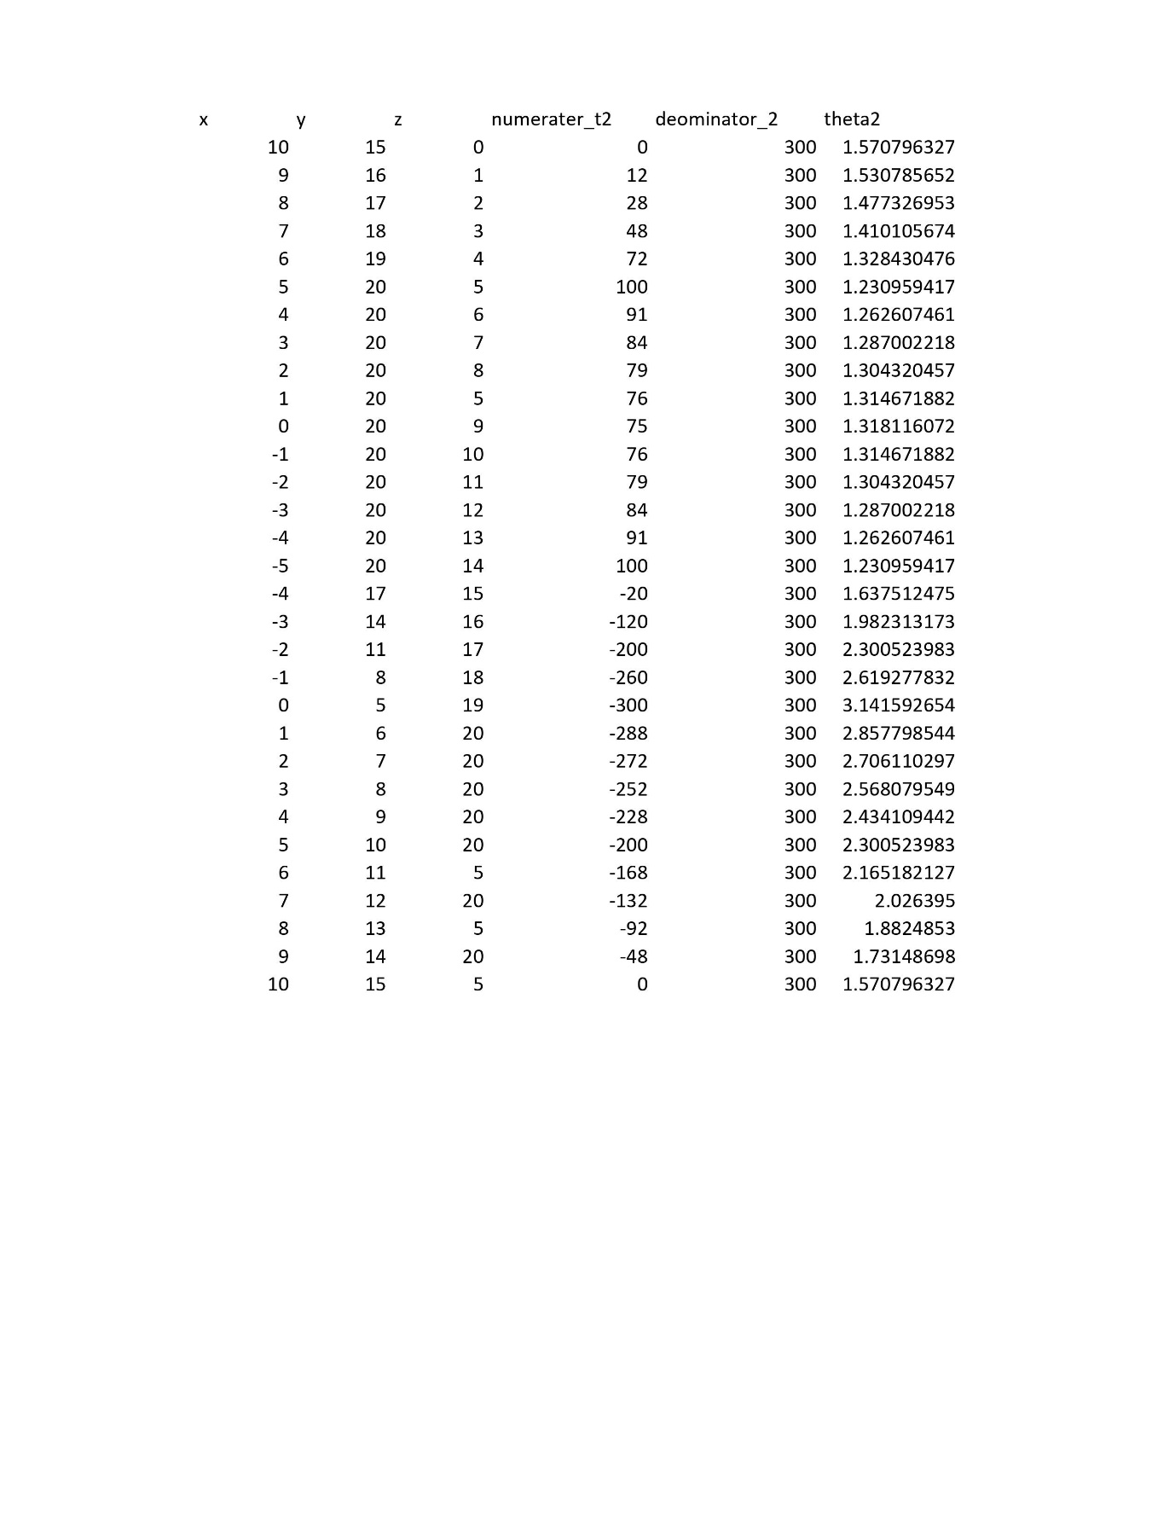

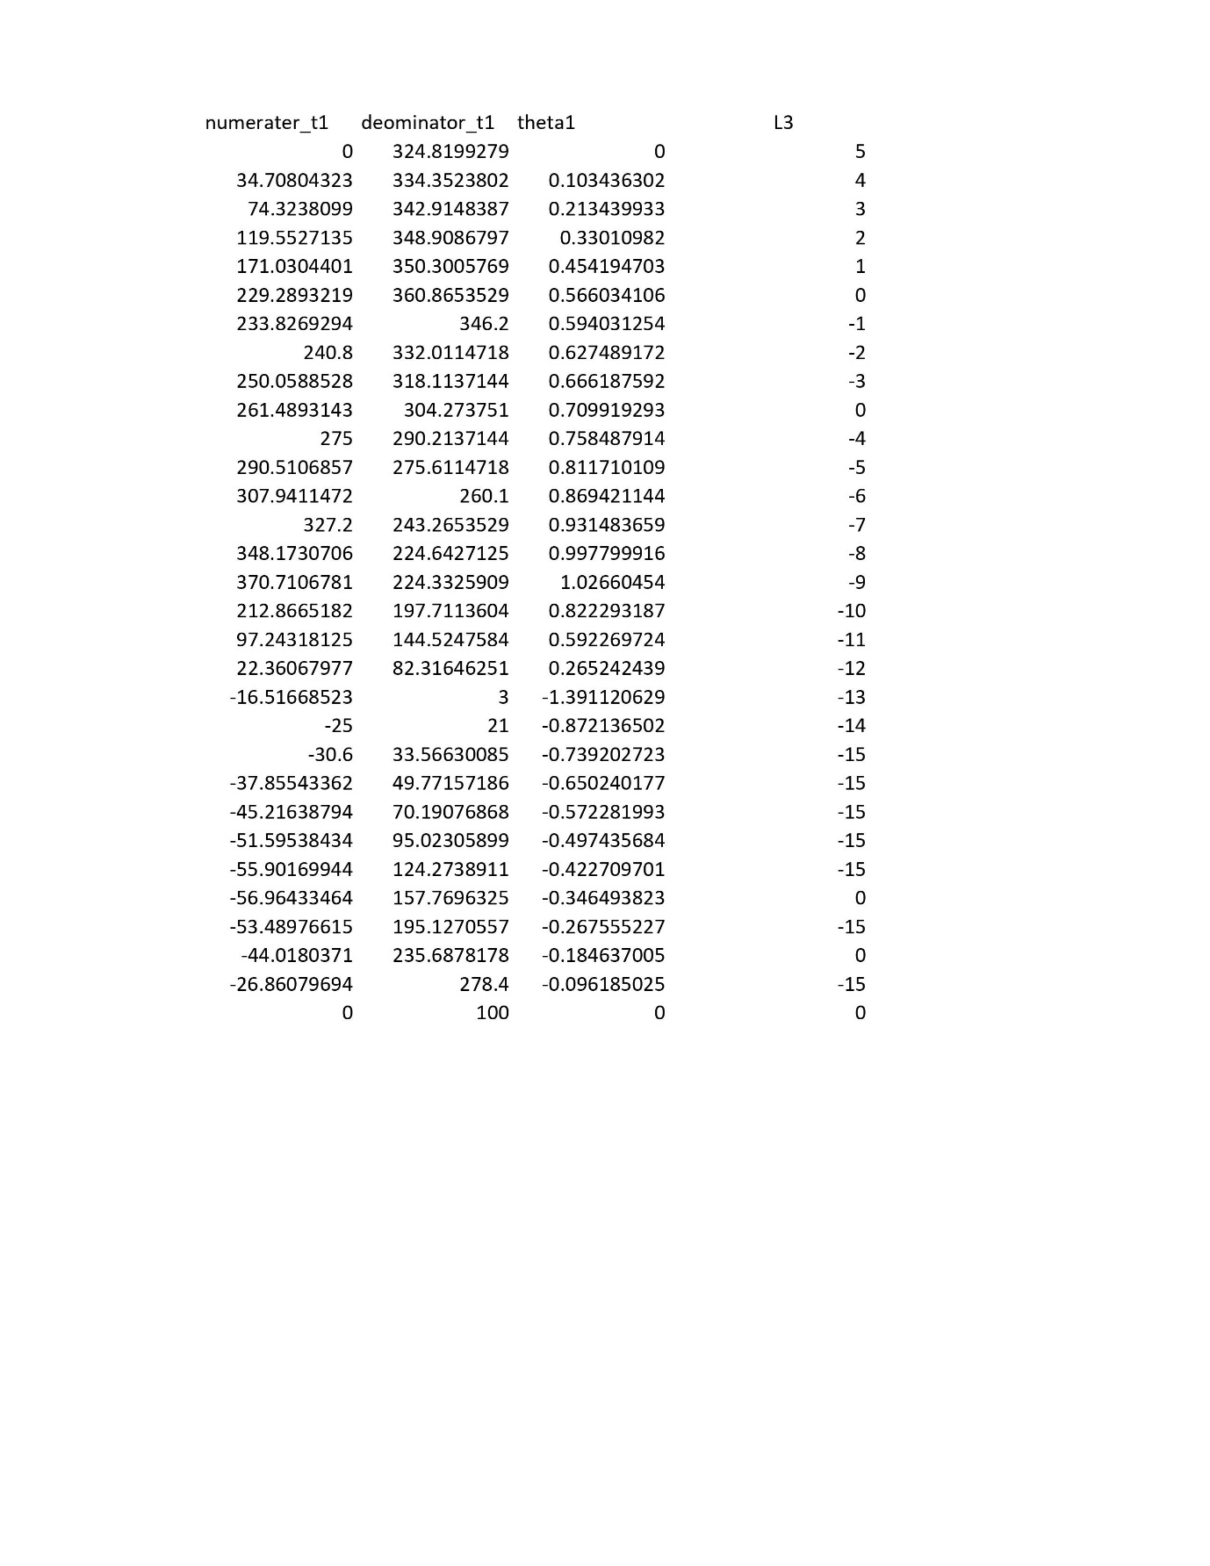

1. This value will be inserted in DH matrix to get the desired movement of the links.

**Using MATLAB and RTB toolbox**

1. Creating robot

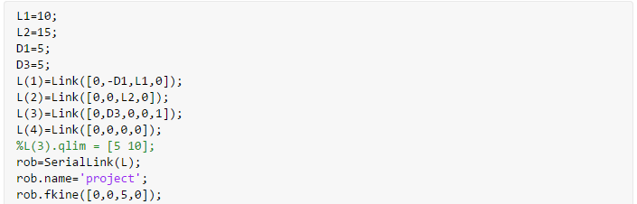

1. Path (since my MATLAB version does not support ‘readmatrix’ command the path is imported manually)

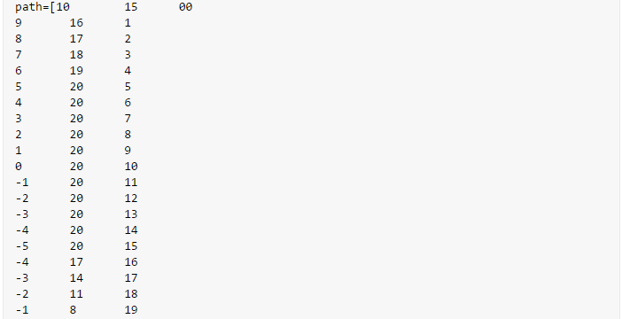

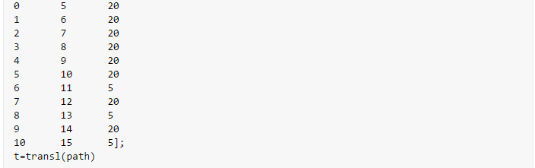

1. The inverse kinematic command (MATLAB use iteration to get the values, therefore the initial value is important for time taken to reach convergent).



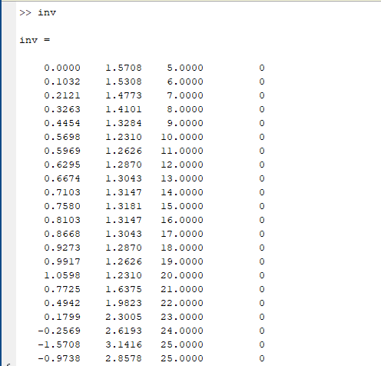

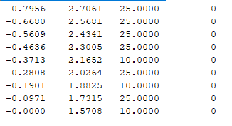

1. The Rotation and translation matrix

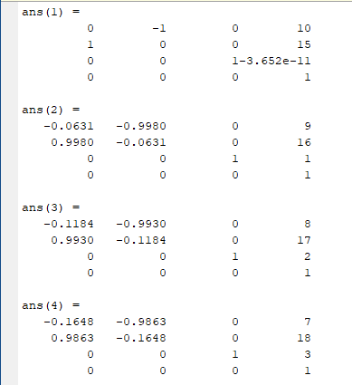

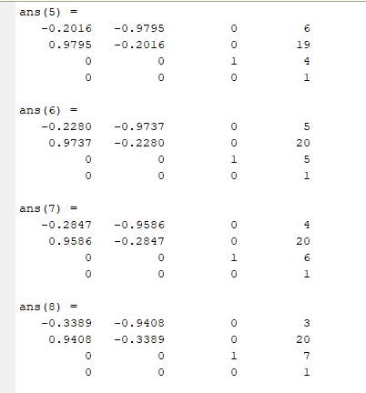

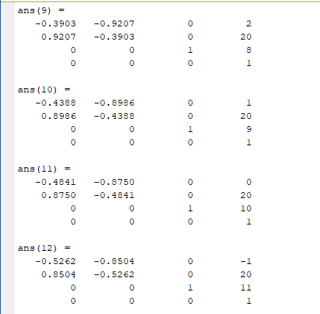



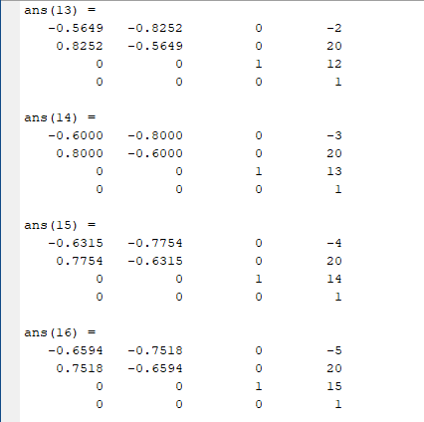

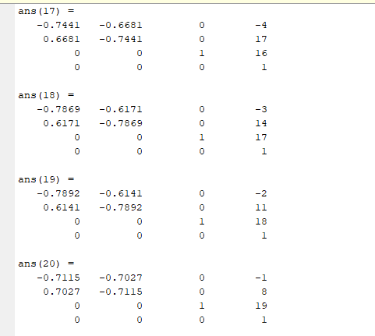

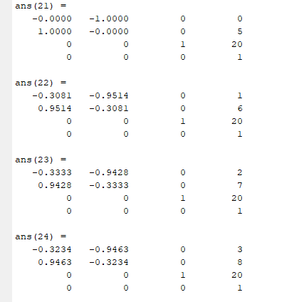

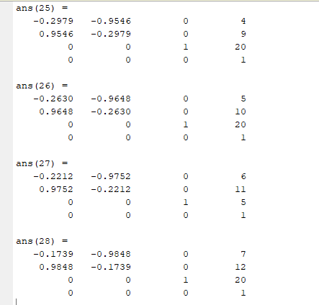

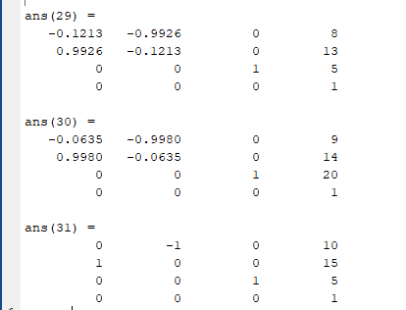

**The robot motions**

* The motion of the robot is as expected, following the closed loop path as predicted
* The glimpse of the robot motion can be seen below, for more of the robot motion the link is (<https://drive.google.com/file/d/1yPpAral_asiXuauAGYYBlTHH_M83aveV/view?usp=sharing> )

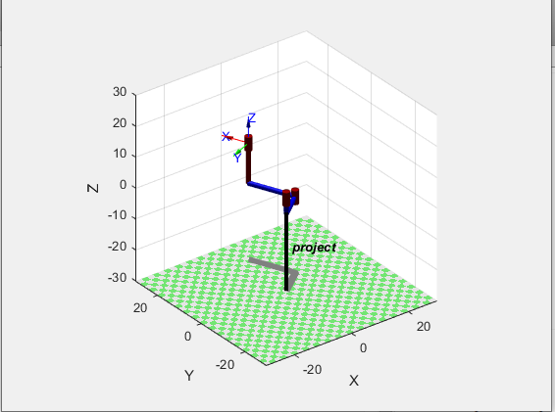

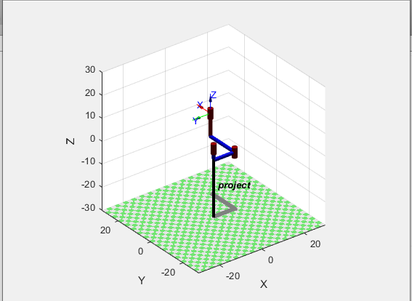

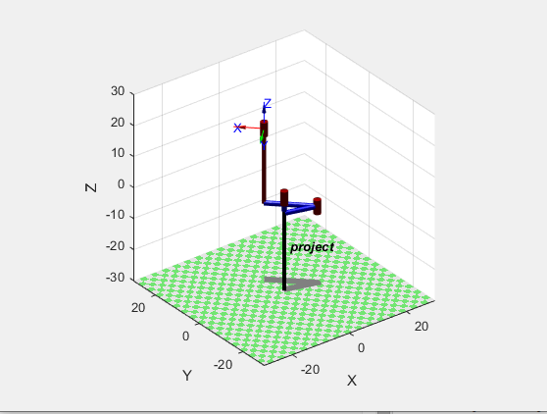

**Result comparison**

1. Using Manually and MATLAB
   1. The result is the same but using MATLAB the process is more accurate and easier to implement.
   2. The motion of the Robot can be observed using MATLAB
2. For continuous and Discrete Z
   1. The continuous Z mean no jerking for z causing the movement of the z smoother.
   2. For discrete, the movement of the z is faster and might damage the robot in real situation.
   3. But to make the closed loop, the motion of z is not very important.

**Conclusion**

* For the project conclusion, using DH, we can make our scara robot follow our desired path considering it is within the limit of the robot.